# Mechanical properties on Metal Additive manufacturing

## Abstract

This dataset contains the results on the experimental procedure to gather data on the manufacturing of Additive Manufacturing (AM) pieces for Laser Metal Deposition (LMD) processes.To create this dataset, a set of 37 pieces were manufactured using the same material and procedure but different manufacturing parameters and strategies. The process was monitored and recorded using the tools described in [1], capturing thermal images and sensor readings on each point of the manufacturing. Each one of the pieces was divided in 4 coupons, that were tested to obtain mechanical properties of resistance and hardness.

*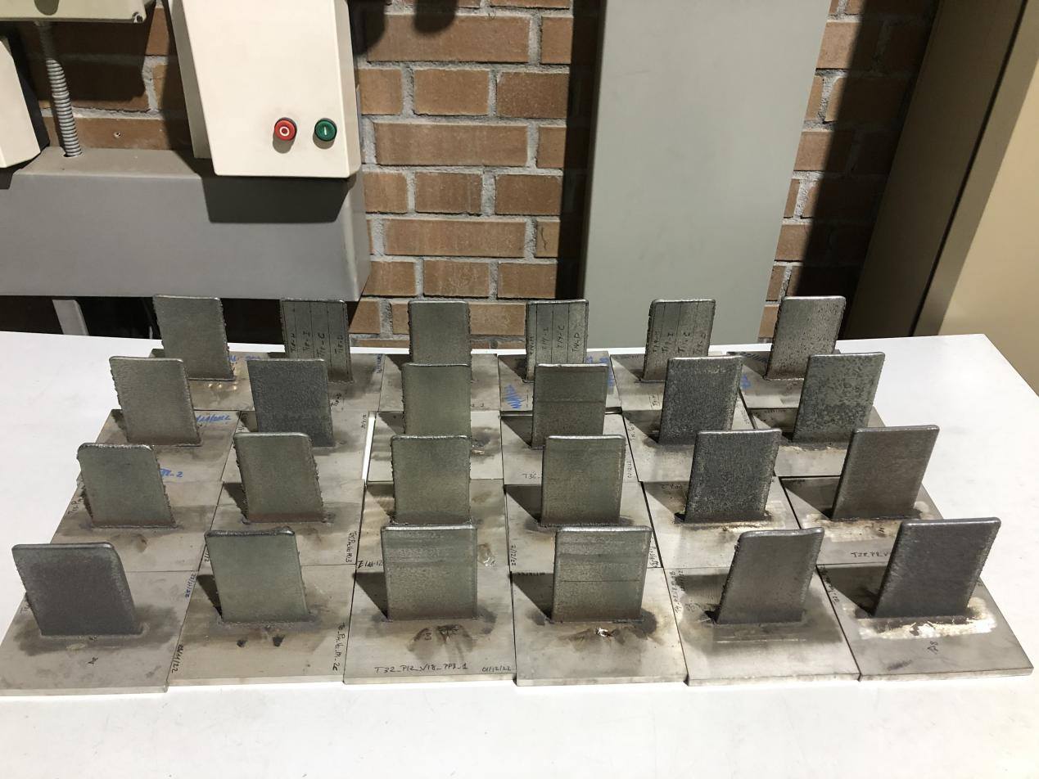Manufactured pieces of the dataset*

## Methodology

In order to produce this dataset, 37 pieces were manufactured in a robotized LMD powder process. To produce variation in the results, different process parameters and strategies were used. The material used for bothe the base plate and the manufacturing in steel 316L. Since the modification of the process parameters have an impact on the width and growth of the pieces, the number of layers and trajectories width were modified so all the pieces had the same approximate final geometry. The infomration on the process pareameters, number of layers and piece dimensions is contained in a table in hte dataset.

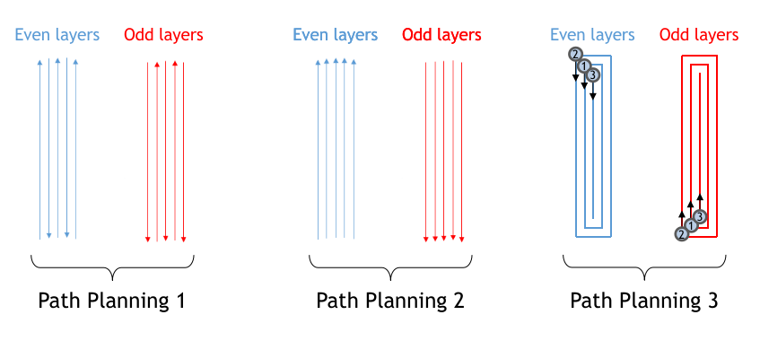

*Path planning strategies used during the manufacturing. For strategy 3, the start point of each trajectory is located with a circle and a number that indicated the order.*

The production process data was collected as a temporal series of data-points that cover the entire process. Each data point contains:

* Position data from the robot.
* Temperature data from thermocouples attached to the base plate
* A thermographic image of the meltpool at the given time.

After manufacturring, the thermal images were analysed with computer vision techniques to calculate the dimensions and emissivity of the meltpool at each time step. These features have been calculated for each data point and are contained in the manufacturing file of each piece.

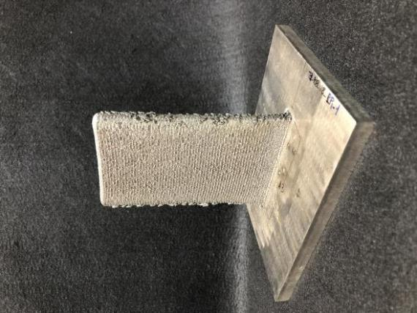 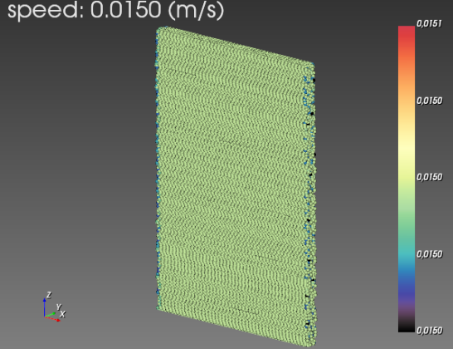

*Example of manufactured piece. Real piece (left), and virtual representation of the process (right) produced with Visualizer software [2]*

Finally, the pieces were destroyed to create coupons to test their mechanical properties. Four coupons were created for each one of the pieces: one to analyse hardness and 3 to analyse traction. Most of the coupons were tested, and the results were gathered in a table contained in the dataset.

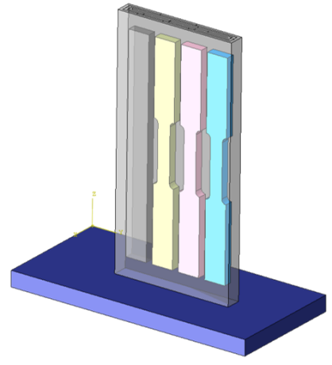 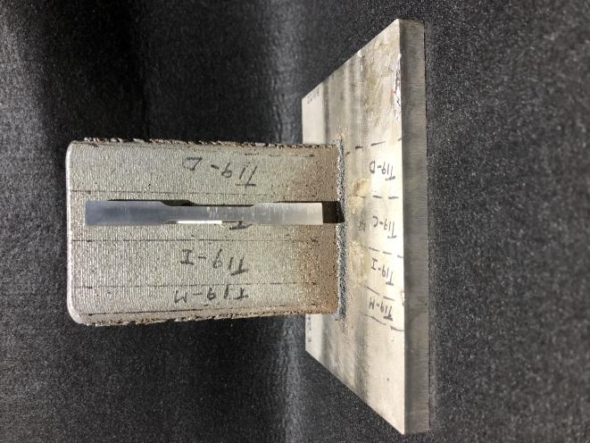

*Extraction of mechanical coupons from each piece. From left to right, the coupons are referenced: M (gray), I (yellow), C (pink), D (blue)*

## Contents

This dataset contains data related to 37 coupons (named T1 - T37), including the monitoring data gathered during manufacturing, the process parameters, results of tensile testing, results of hardness testing and pictures of the coupons.

The dataset is structured as follows:

* Dataset:
* [Piece ID]
* Hdf5 file
* Piece picture
* Piece crosssection
* Testing
* Piece crosssection
* Parameters.csv: tabular data with process parameters and piece measurements as a direct result of the manufacturing
* Coupons.csv: tabular data with tensile and hardness metrics on the tested coupons for each piece
* README: explicative document

## Formats

The data is provided in the following formats:

* Monitoring: HDF5 file format. This format allows the recording of multimodal manufacturing data. The specific structure of the file is described in [1]. Overall, each file contains the following tables:
  + Data0: table with data from the sensors, thermocouples and motion system. Each data point is associated with a {x, y, z} coordinate within the piece.
  + Image_data0: table with thermal images of the manufacturing process. Each image is associated with a data0 data point, and their correspondent coordinates.
  + Features: table with calculated features for each data point. The features calculated are listed here:
    - process_status
    - Speed
    - meltpool_width
    - meltpool_length
    - meltpool_area
    - meltpool_ratio
    - meltpool_max
    - meltpool_mean
    - meltpool_std
    - meltpool_min
    - meltpool_gradient
* Pictures: jpg format
* Parameters: csv file containing the following columns:
  + ID: ID of the piece
  + Power [W]: Laser power used in the manufacturing. This value is constant for each piece
  + Speed [mm/s]: manufacturing speed used in the manufacturing. This value is set for each piece, but small discrepancies can be found due to the movement system. A more precise reading of speed can be found in the monitoring files.
  + Material [g/min]: Average material flow used in the manufacturing.
  + Strategy: ID of the path planning strategy used. Can be 1, 2, or 3
  + Power density [W/mm2]: Estimation of the average power density for each piece.
  + Energy density [J/mm2]: Estimation of the average energydensity for each piece.
  + Number of layers: Number of layers used for the manufacturing of each piece. This value changes due to the different layer height caused by varying the manufacturing parameters.
  + Layer height [mm]: Average layer height of piece.
  + Wall width [mm]: Average piece width.
* Coupons:
  + ID: ID of the piece where the coupon comes from
  + Coupon: ID of the coupon within the piece
  + {X1,X2,Y1,Y2,Z1,Z2}: Coordinates of the bounding box in the piece where the coupon is located. The coordinates are stored as [min, max] for each axis.
  + Rp0.2 [Mpa]
  + Rp1 [Mpa]
  + Rm [Mpa]
  + E [Gpa]
  + A [25mm] (%)
  + Average Vickers hardness [HV03]
  + STD Vickers hardness [HV03]

The following software tools are suggested for visualization and exchange of the data:

* HDF5: Visualizer [2] or Hdfview [3]
* Csv: Microsoft Excel or text editor

## **References**

1. Gonzalez-Val Carlos, Lodeiro Baltasar, & Diez Marcos. (2020). Metal Additive Manufacturing Open Repository (2.0) [Data set]. Zenodo. <https://doi.org/10.5281/zenodo.5031586>
2. Carlos González Val, Roberto Fernández Molanes, & Baltasar Lodeiro Señarís. (2021). Visualizer (3.0.1). Zenodo. https://doi.org/10.5281/zenodo.5469946
3. <https://www.hdfgroup.org/downloads/hdfview/>